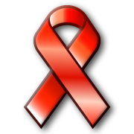
Red Ribbon Week

Washington Elementary students will be celebrating Red Ribbon Week the week of October 5th-9th. This week is a time to learn about the harmful effects of drugs and alcohol and to help students make wise decisions about their health.

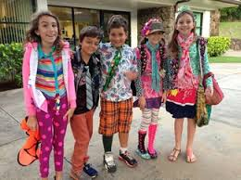
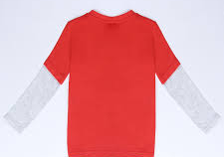
Monday, October 5th - “ “Red”y To Live A Drug Free Life.” Students wear red to school.

Tuesday, October 6th - “Don’t Let Drugs Mix You Up.” Students wear mismatched clothing.
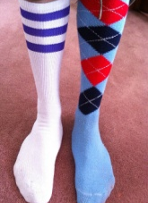
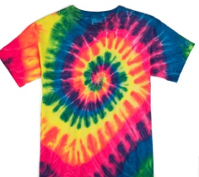
Wednesday, October 7th - “Sock It To Drugs.” Students wear crazy socks.

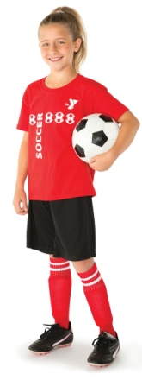
Thursday, October 8th - “I’m Too Bright For Drugs.” Students wear brightly colored clothes.
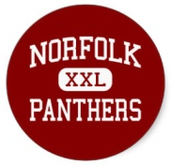
Friday, October 9th - “Team Up Against Drugs.” Students wear any team apparel – including panthers!

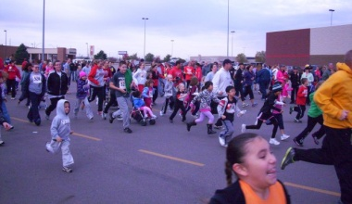
Saturday, October 10th – Red Ribbon Run at the Sunset Plaza, beginning at 8:30 a.m. (see Mr. Long, P.E. teacher, for information)

We hope students learn the value of choosing to live a healthy life while also having a little fun.

Sincerely,
Washington Elementary Staff

